VALUER REPORT UID NO.:CEV/RVO/299/4156/ 16022025 16.02.2025

To
The Branch Manager
Bank of Baroda ,
Branch :Sector-11 Panchkula (HR.)

VALUATION REPORT ( IN RESPECT OF FLATS / SITE AND BUILDING)
I | General
1. | Name of Applicant/ Prospective & Their shares and Mob/Phone No |  |  |  |  | Sh. Satya Veer Singh S/o Late Sh. Karam Chand Kothari  Mobile No.9316608777
2. | Name of Reported /legal owner(s) & their shares & their Mob/Phone No. |  |  |  |  | Sh. Satya Veer Singh S/o Late Sh. Karam Chand Kothari  Mobile No. 9316608777
3. | Purpose of valuation |  |  |  |  | For Assessing present value of the asset for Bank purposes
4. | List of documents produced in support of Perusal |  |  |  |  | 1.Conveyance deed:- Serial no. 1518, Dated:- 10.09.2013  (All data referred from valuation report dated :- 24.04.2018 by Sharma & Associates ( AR. Jatinder Sharma ) because no other documents provided by the bank
5. | Location/ Description of the Property |  |  |  |  | Flat No. 5-A, 2nd Floor , The Postal Co-Operative Housing Society Ltd. MDC ,GH-38, Sector-5, Panchkuka Distt. Panchkula (HR.) PIN:- 134114
6. | Postal address of Property/Asset |  |  |  | : | Flat No. 5-A, 2nd Floor , The Postal Co-Operative Housing Society Ltd. MDC ,GH-38, Sector-5, Panchkuka Distt. Panchkula (HR.) PIN:- 134114
7. | Boundaries of the property |  |  |  |  | -
 | North |  |  |  |  | Road
 | South |  |  |  |  | Another Society
 | East |  |  |  |  | GH-37
 | West |  |  |  |  | Road
8. | Details of Corporation Tax Paid |  |  |  | : | NA
9. | Details of Approval If not as per approved plan, has Compounding been done |  |  |  |  | NA, Flat is already constructed by The Postal Co. Operative Housing Society Ltd. & Occupied
10. | General remarks, if any
 | VALUATION DETAILS |  |  |  | : | NA, being flat
 | Land |  |  |  | : | Lats. 30⁰43’3” N & Long. 76⁰51’12”E
 | 1.Total Area (Extent) of the site/land |  |  |  | : | Covered Area = 1315.05 sft & Carpet area= 1117.79 sft(85% OF Covered area assumed )
 | 2.Extent of site considered for Valuation |  |  |  | : | Covered Area = 1315.05 sft
11. | Classification of the area |  |  |  |  | -
11. |  | a)Agricultural/Residential b)Commercial/Industrial area |  |  | : | Residential
 |  | c)Higher Income/ Middle/ Poor d)Urban/Semi/Rural |  |  |  | Middle  Urban
 |  | CHARACTERISTICS OF THE SITE  Distance from civic amenities such as : School, College, Market, Nursing Home, Bus Stop, Railway Station etc |  |  |  | 200 m to 2.0 km
1. | Possibility of frequent flooding |  |  |  |  | Only in case of natural calamites
2. | Topographical conditions |  |  |  |  | Plain
3. | Shape of land |  |  |  |  | Rectangular
4. | And usage restriction |  |  |  |  | Property can be used for residential purposes Only
5. | Is plot /Land in Town Planning approved layout? |  |  |  |  | Yes
6. | Corner plot or inside plot/flat |  |  |  |  | Inside flat
7. | Type of road available at site |  |  |  |  | Black top road
8. | Water potential/ Source |  |  |  |  | Yes
9. | Underground sewage system |  |  |  |  | Yes
10. | Power supply availability at site |  |  |  |  | Yes
11. | Advantage of site |  |  |  |  | Clean, Calm & quiet environment, ideal for family living.
 | BUILDING
1. | Type of construction |  |  |  | : | RCC framed
2. | Quality of Construction |  |  |  | : | 1st Class
3. | Appearance of the Building |  |  |  | : | Good
4. | Number of Floors |  |  |  | : | 5
5. | Maintenance of the Building |  |  |  | : | Good
 | Technical Specifications of Building: |  |  |  | :
 | a) |  | Foundation |  | : | NA, being 2nd floor
 | b) |  | Superstructure |  | : | Brick masonry in cement sand mortar
 | c) |  | Roof |  | : | RCC slab
 | d) |  | Door and Windows |  | : | Hard wood
 | e) |  | Flooring |  | : | Marble flooring
 | f) |  | Sanitary fittings |  | : | Yes
 | g) |  | Electricity Supply |  |  | Yes
 | Life of the Asset |  |  |  |  | About 18 years , also seems by physical appearance
 | Residual life of Property/Asset |  |  |  |  | 57 years
 | Part-II :- Valuation of Flat
1. | Undivided Share of Land (if applicable) |  |  |  |  | Not known to client
2. | Adopted unit composite Rate (per Sft of Area) |  |  |  |  | Rs. 9900 sft (Composite rate land & Building Considered for the valuation)
3. | Covered Area of the Flat |  |  |  |  | 1315.05 sft
 | Agreement Value of the Flat |  |  | Unit Rate |  | Market Value
 | Not Applicable |  |  | Not Applicable |  | 1315.05 x 9900 =1,30,18,995/- Say Rs. 130.00 lac
 | Fair Market Value |  |  |  |  | 130.00 lac ( Seventy nine lac seventy four thousand only)
 | Realizable Value |  |  |  |  | 117.00 lac( Seventy one lac seventy six thousand only)
 | Distress Value |  |  |  |  | 97.50 lac ( Fifty nine lac eighty thousand)
 | Collector Rate for Flat |  |  |  |  | Rs. 5750/-per sft (copy enclosed)

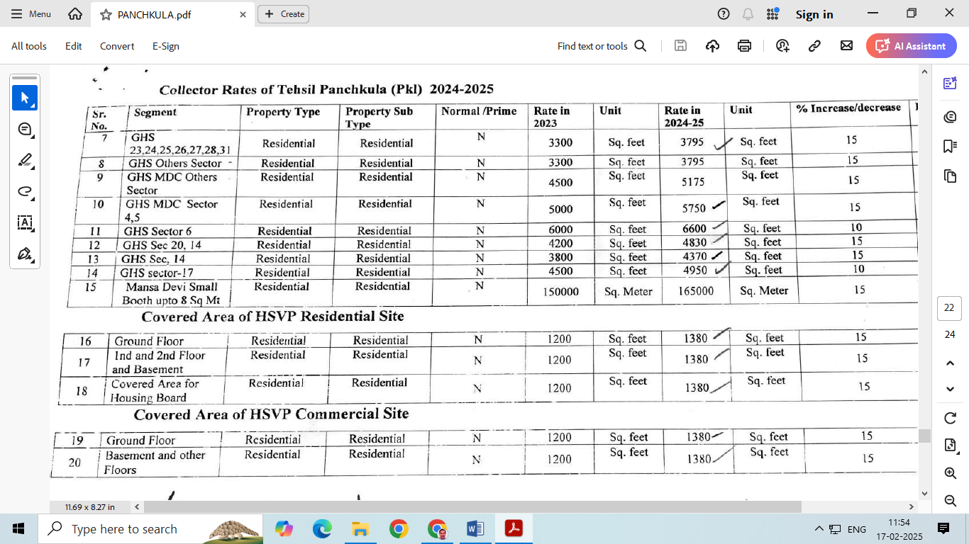
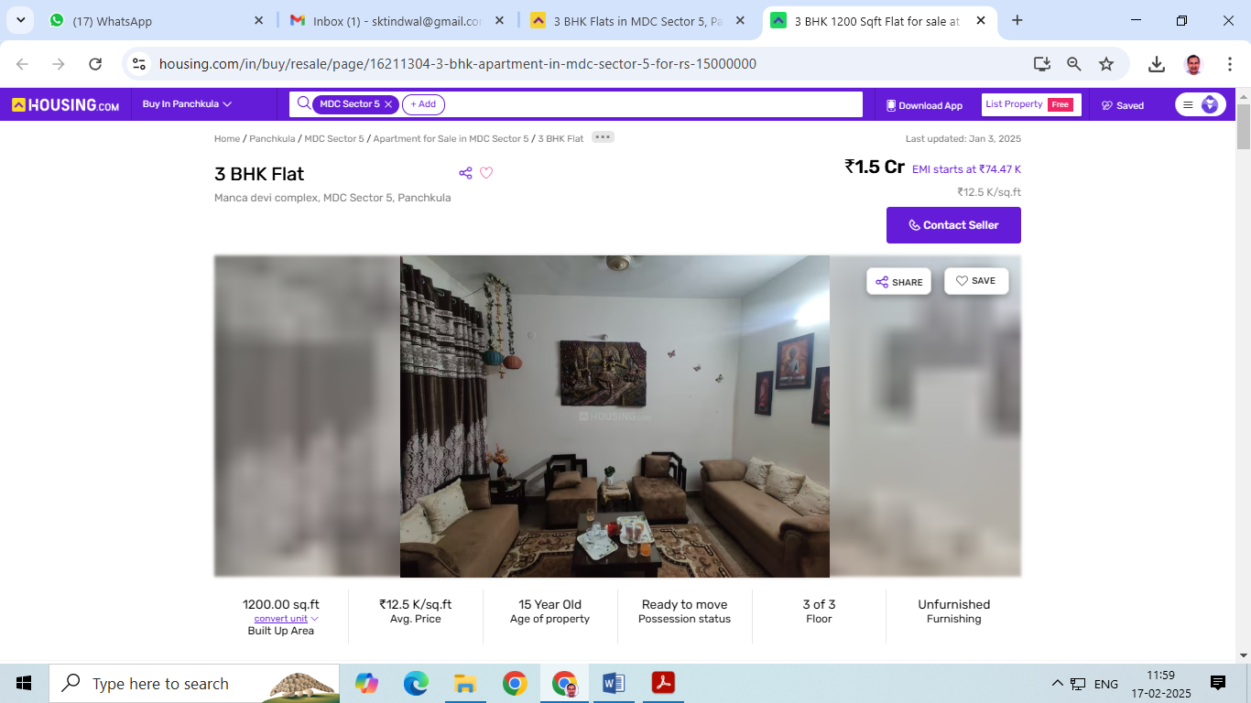

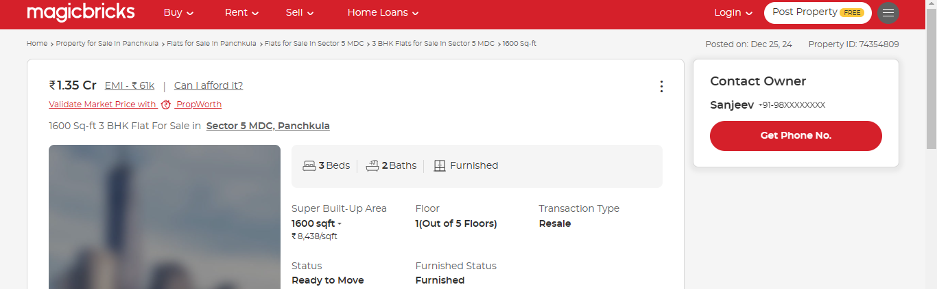
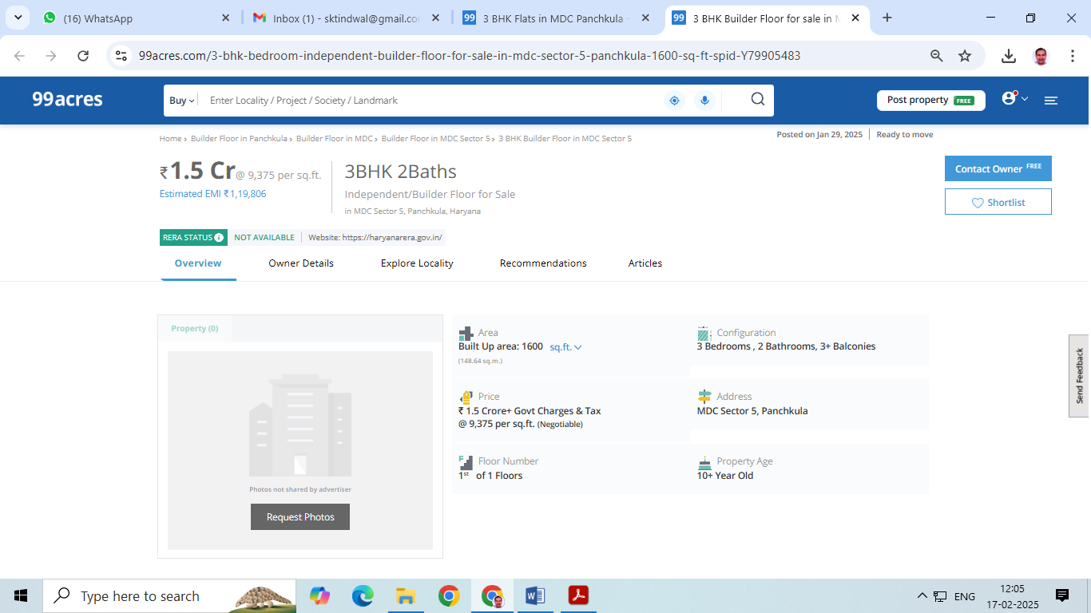
Photos of Flat No. 5-A, 2nd Floor , The Postal Co-Operative Housing Society Ltd. MDC ,GH-38, Sector-5, Panchkuka Distt. Panchkula
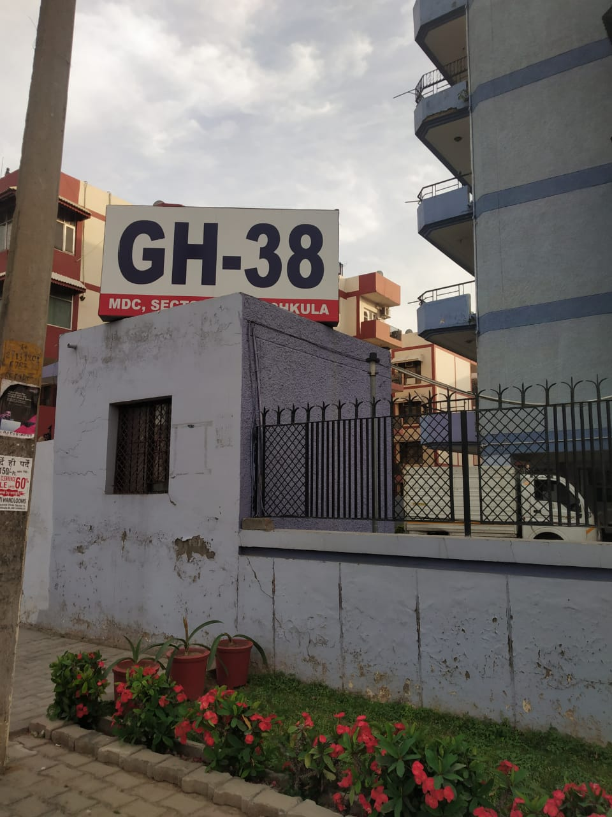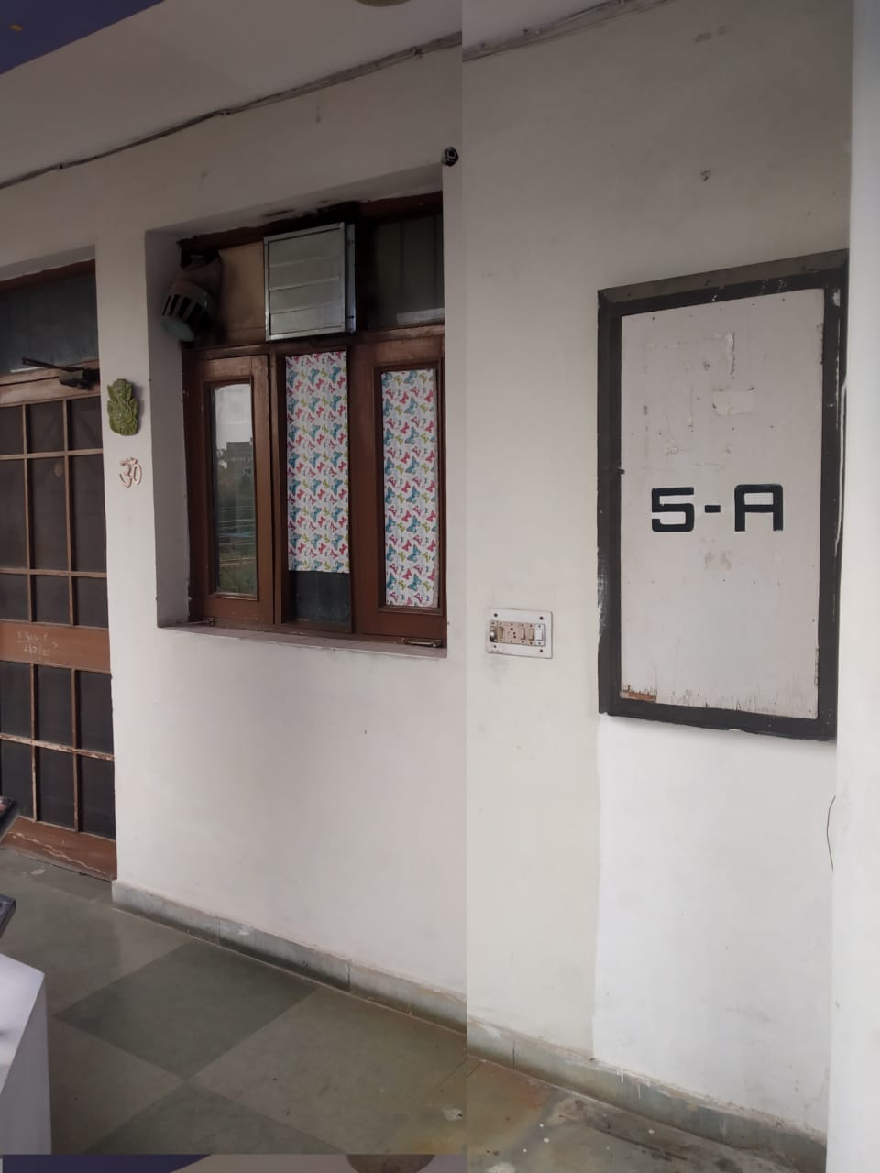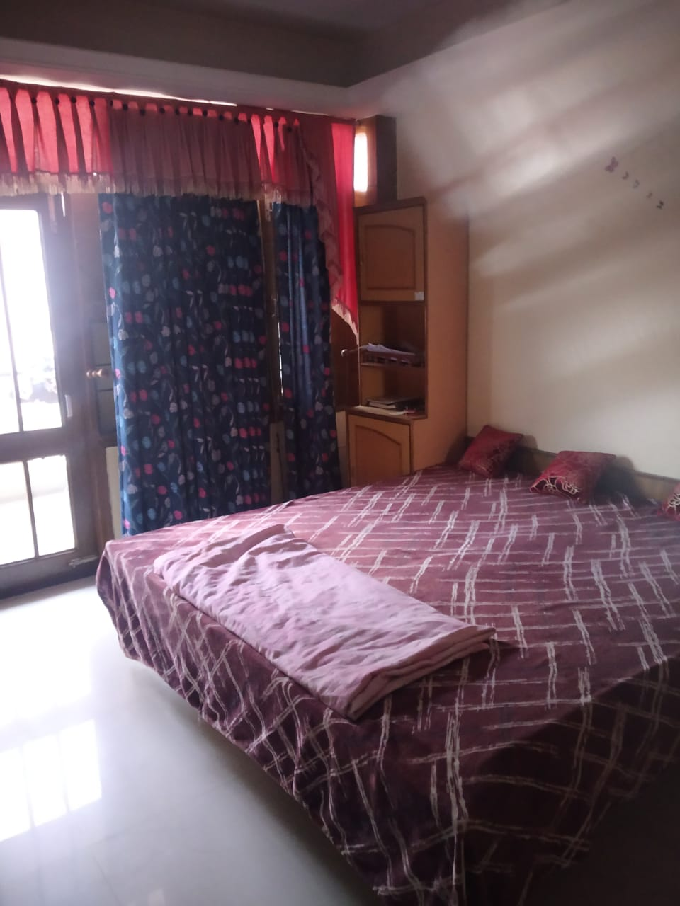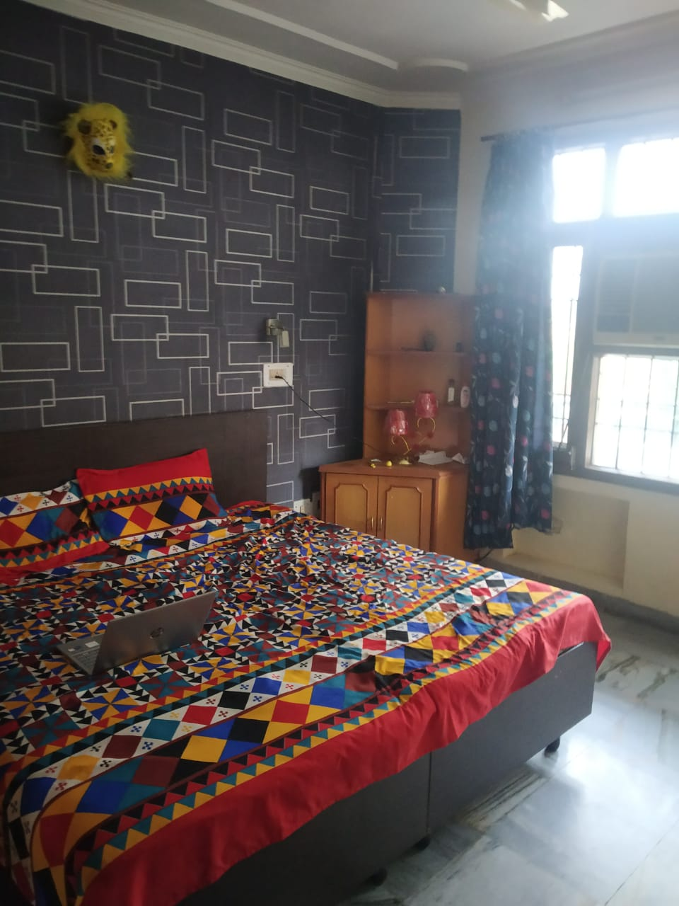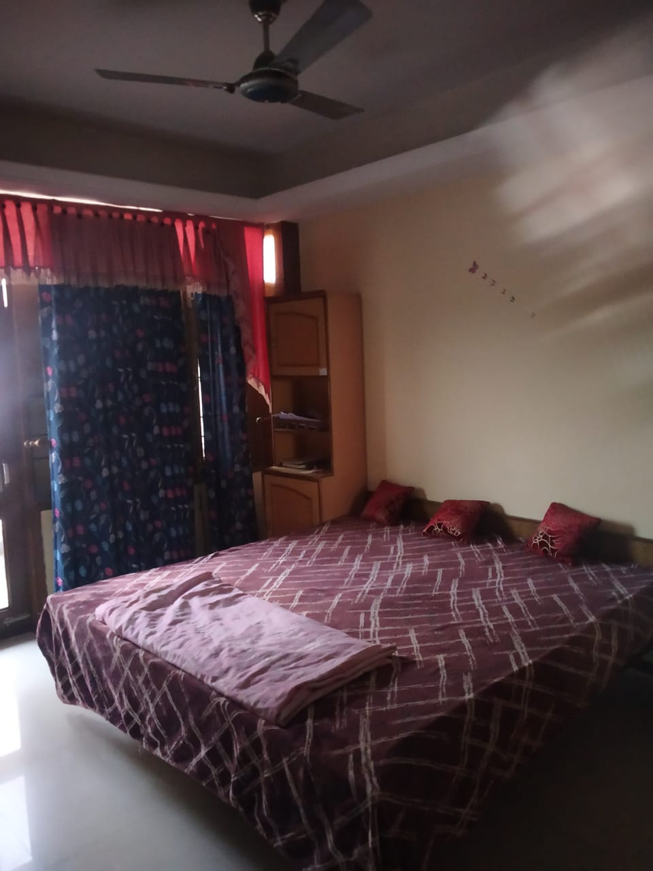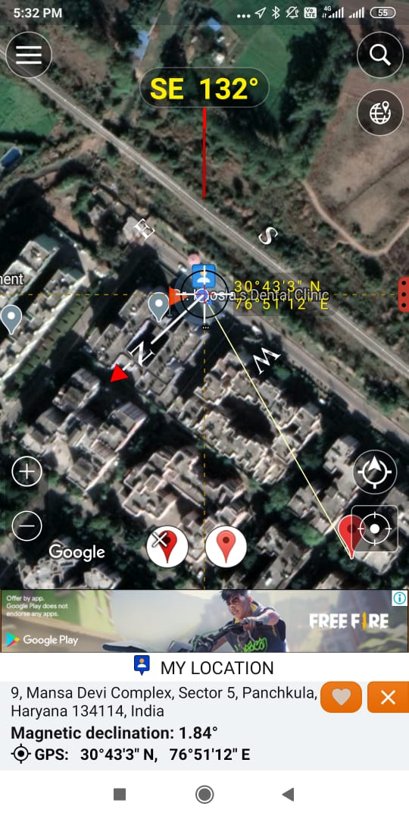
Google Location

Signature of Valuer

Annexure-I
Format of undertaking to submitted by Individuals/proprietor/partners/direction DECLARATION-CUM-UNDERTAKING

I,Surinder Kumar Tindwal son of Late Sh. Chhelu Ram do hereby solemnly affirm and state that: a. I am a citizen of India b. I will not undertake valuation of any assets in which I have a direct or indirect interest or become so interested at any time during a period of three years prior to my appointment as valuer or three years after the valuation of assets was conducted by me c. The information furnished in my valuation report dated DD.MM.YYYY is true and correct to the best of my knowledge and belief and I have made an impartial and true valuation of the property. d. I have personally inspected the property on DD.MM.YYYY The work is not subcontracted to any other valuer and carried out by myself. e. Valuation report is submitted in the format as prescribed by the Bank f. I have not been depanelled/ delisted by any other bank and in case any such depanelment by other banks during my empanelment with you, I will inform you within 3 days of such depanelment. f. I have not been removed/dismissed from service/employment earlier g. I have not been convicted of any offence and sentenced to a term of imprisonment h. I have not been found guilty of misconduct in professional capacity L have not been declared to be unsound mind J. I am not an undischarged bankrupt, or has not applied to be adjudicated as a bankrupt; k. I am not an undischarged insolvent L. I have not been levied a penalty under section 2711 of Income-tax Act, 1961 (43 of 1961) and time limit for filing appeal before Commissioner of Incometax (Appeals) or income-tax Appellate Tribunal, as the case may be has expired, or such penalty has been confirmed by Income-tax Appellate Tribunal, and five years have not elapsed after levy of such penalty m. I have not been convicted of an offence connected with any proceeding under the Income Tax Act 1961, Wealth Tax Act 1957 or Gift Tax Act 1958 and n. My PAN Card number/Service Tax number as applicable is o. I undertake to keep you informed of any events or happenings which would make me ineligible for empanelment as a valuer

I have not concealed or suppressed any material information, facts and records and I have made a complete and full disclosure q. I have read the Handbook on Policy, Standards and procedure for Real Estate Valuation, 2011 of the IBA and this report is in conformity to the "Standards" enshrined for valuation in the Part-B of the above handbook to the best of my ability r. I have read the International Valuation Standards (IVS) and the report submitted to the Bank for the respective asset class is in conformity to the "Standards" as enshrined for valuation in the IVS in "General Standards" and "Asset Standards" as applicable s. I abide by the Model Code of Conduct for empanelment of valuer in the Bank (Annexure V-A signed copy of same to be taken and kept along with this declaration) t. I am registered under Section 34 AB of the Wealth Tax Act, 1957. (Strike off, if not applicable) u. I am valuer registered with Insolvency & Bankruptcy Board of India (IBBI) (Strike off, if not applicable) v. My CIBIL Score and credit worthiness is as per Bank's guidelines, w. I am the proprietor/partner/authorized official of the firm/company, who is competent to sign this valuation report. x. I will undertake the valuation work on receipt of Letter of Engagement generated from the system (i.e. LLMS/LOS) only. y. Further, I hereby provide the following information.

Sl No. | Particulars | Valuer’s comment
1 | background information of the asset being valued; | Flat No. 5-A, 2nd Floor , The Postal Co-Operative Housing Society Ltd. MDC ,GH-38, Sector-5, Panchkuka Distt. Panchkula
2 | purpose of valuation and appointing authority | Bank’s purpose
3 | identity of the valuer and any other experts involved in the valuation; | Surinder Kumar Tindwal
4 | disclosure of valuer interest or conflict, if any; | No
5 | date of appointment, valuation date and date of report: | 16.02.2025, 16.02.2025, 16.02.2025
6 | inspections and/or investigations undertaken; | Inspection on 16.02.2025 and meeting/ discussion/inquiry with property consultants of the area
7 | nature and sources of the information used or relied upon; | Real estate web portals and property consultants of the area
8 | procedures adopted in carrying out the valuation and valuation standards followed; | Market approach adopted being the property non income fetching and marketable
9 | restrictions on use of the report, if any; | For exclusive use of BOB,Br.: SECTOR -11,PANCHKULA and no other else.
10 | major factors that were taken into account during the valuation; | Location, size, direction, frontage along road, specifications used in building and workmanship
11 | major factors that were not taken into account during the valuation; | NA
12 | Caveats, limitations and disclaimers to the extent they explain or elucidate the limitations faced by valuer, which shall not be for the purpose of limiting his responsibility for the valuation report. | i. I/We have not verified the title deeds of the properties with the records of registrar’s office as this is beyond the agreed scope of our services stated in our engagement letter.  ii. I/We assume no responsibility for the legal matters including, but not limited to, legal or title concerns. The assets and interests therein have been valued free and clear of any liens or encumbrances unless stated otherwise. No hidden or apparent conditions regarding the subject assets or their ownership are assumed to exist. No opinion of title is rendered by this report and a good title is assumed.  iii. The RV has endeavoured to visually identify the land boundaries and dimensions; however, he is not a surveyor. So where there is a doubt about the precise position of the structures, it is recommended that a Licensed Surveyor be contacted.  iv. The physical condition of the improvements was based on visual inspection. No liability is assumed for the soundness of the structure since no engineering tests were made at the site. Any unknown conditions existing at the time of inspection could alter the value. No responsibility is assumed for latent defects of any nature whatsoever, which may affect value, nor for any expertise required to disclose such conditions.  v. Where a sketched plan is attached to this report, it does not purport to represent accurate architectural plans. Sketch plans and photographs are provided as general illustrations only.  vi. Unless otherwise stated as part of the terms of engagement, the RV has not made a specific compliance survey or analysis of the various permits and licenses under central, state and local laws / regulations applicable to the operation and use of the subject property, and this valuation does not consider the effect, if any, of non-compliance.  vii. The sale of the subject property is assumed to be on an all cash basis. Financial arrangements would affect the price at which the property may sell for if placed on the market.  viii. Value varies with the purpose and date. This report is not to be referred if the purpose is different other than mentioned.  ix. The actual realizable value that is likely to be fetched upon sale of the property under consideration shall entirely depend on the demand and supply of the same in the market at the time of sale.  x. In the course of the valuation, we were provided with both written and verbal information. We have however, evaluated the information provided to us by the Company through broad inquiry, analysis and review but have not carried out a due diligence or audit of the information provided for the purpose of this engagement. Our conclusions are based on the assumptions, forecasts and other information given by/on behalf of the Company.  xi. We are independent of the client/company and have no current or expected interest in the Company or its assets. The fee paid for our services in no way influenced the results of our analysis.  xii. Our report is meant for the purpose mentioned above and should not be used for any purpose other than the purpose mentioned therein. The Report should not be copied or reproduced without obtaining our prior written approval for any purpose other than the purpose for which it is prepared.

Date:16.02.2025
Place:Panchkula

Signature
(Name of the approved valuer and seal of the Firm/company)

Annexure -II
MODEL CODE OF CONDUCT FOR VALUERS

All the empanelled Valuers are required to adhere to the code of conduct given as under:
Integrity and Fairness:
1. A Valuer shall, in the conduct of his/its business, follow high standards of integrity and faimess in all its dealings with his/its clients and other Valuers
2. A Valuer shall maintain integrity by being honest, straightforward, and forthright in all professional relationships.
3. A Valuer shall endeavor to ensure that he/it provides true and adequate information and shall not misrepresent any facts or situations.
4. A Valuer shall refrain from being involved in any action that would bring disrepute to the profession 5. A Valuer shall keep public interest foremost while delivering his services
5. A Valuer shall keep public interest foremost while delivering his services.
Professional Competence and Due Care:
6. A Valuer shall render at all times high standards of service, exercise due diligence, ensure proper care and exercise independent professional judgments
7. A Valuer shall carry out professional service in accordance with the relevant technical and professional standards that may be specified from time to time.
8. A Valuer shall continuously maintain professional knowledge and skills to provide competent professional service based on up to date developments in practice, prevailing regulations/guidelines and techniques.
9. In the preparation of a Valuation report, the Valuer shall not disclaim liability for his/its expertise or deny his/its/duty of care, except to the extent that the assumptions are based on statements of fact provided by the company or its auditors or consultants or informationavailable in public domain and not generated by the Valuer
10. A Valuer shall not carry out any instructions of the client insofar as they are incompatible with the requirements of integrity.objectivity and independence.
11. A Valuer shall clearly state to his client the services that he would be competent to provide and the services for which he would be relying on other Valuers or professionals or for which the client can have a separate arrangement with other Valuers.
Independence and Disclosure of Interest:
12. A Valuer shall act with objectivity in hisfits professional dealings by ensuring that his/its decisions are made without the presence ofany bias, conflict of interest, coercion, or undue influence of any party, whether directly connected to the Valuation assignment or not.
13. A Valuer shall wherever necessary disclose to the clients, possible sources of conflicts of duties and interest providing unbiasedservices
14. A Valuer shall maintains complete independence in his/its professional relationships and shall conduct the Valuation independent ofexternal influences
15. A Valuer shall not deal in securities of any subject company after any time when he/it first becomes aware of the possibility of his/its association with the Valuation, and in accordance with Bank of India the Securities and Exchange Board of India (Prohibition of Insider Trading) Regulations, 2015 or till the time the Valuation report becomes public, whichever is earlier.
16. A Valuer shall not indulge in mandate snatching or offering 'convenience Valuations' in order to cater to a company or client's needs
17. As an independent Valuer, the Valuer shall not charge success fee (success may be defined as a compensation/ incentive paid to any third party for successful closure of transaction. In this case, approval of credit proposals).
18. In any faimess opinion or independent expert opinion submitted by a Valuer, if there has been a prior engagement in anunconnected transaction, the Valuer shall declare the association with the company during the last five years.
Confidentiality:
19. A Valuer shall not use or divulge to other clients or any other party any confidential information about the subject company, which has come to his/its knowledge without proper and specific authority or unless there is a legal or professional right or duty to disclose.
Information Management:
20. A Valuer shall ensure that he/it maintains written contemporaneous records for any decision taken, the reasons for taking thedecision, and the information and evidence in support of such decision. This shall be maintained so as to sufficiently enable areasonable person to take a view on the appropriateness of his/its decisions and actions.
21. A Valuer shall appear, co-operate and be available for inspections and investigations carried out by the authority, any person authorized by the authority, the registered Valuers organization with which he/it is registered or any other statutory regulatory body.
22. A Valuer shall provide all information and records as may be required by the authority, the Tribunal, Appellate Tribunal, the
registered Valuers organization with which he/it is registered, or any other statutory regulatory body.
23. A Valuer while respecting the confidentiality of information acquired during the course of performing professional services shall maintain proper working papers for a period of three years or such longer period as required in its contract for a specific Valuation, for production before a regulatory authority or for a peer review. In the event of a pending case before the Tribunal or Appellate Tribunal,the record shall be maintained till the disposal of the case.
Gifts and Hospitality:
24. A Valuer or hisfits relative shall not accept gifts or hospitality which undermines or affects his independence as a Valuer.
Explanation-For the purposes of this code the term 'relative' shall have the same meaning as defined in clause (77) of section 2 of the companies Act, 2013 (18 of 2013).
25. A Valuer shall not offer gifts or hospitality or a financial or any other advantage to a public servant or any other person with a view to obtain or retain work for himself/itself, or to obtain or retain an advantage in the conduct of profession for himself/itself.
Remuneration and Costs:
26. A Valuer shall provide services for remuneration which is charged in a transparent manner, is a reasonable reflection of the worknecessarily and properly undertaken, and is not inconsistent with the applicable rules.
27. A Valuer shall not accept any fees or charges other than those which are disclosed in a written contract with the person to whom he would be rendering service.
Occupation, employability and restrictions
28. A Valuer shall refrain from accepting too many assignments, if he/it is unlikely to be able to devote adequate time to each of his/its assignments.
29. A Valuer shall not conduct business which in the opinion of the authority or the registered Valuer organization discredits the profession.

Signature
(Name of the approved valuer and seal of the Firm/company)

